**CODE:**

import pandas as pd

import matplotlib.pyplot as plt

import seaborn as sns

df = pd.read_csv('salary_data.csv')

print(df.head())

df.dropna(subset=['Entry Salary', 'Junior Salary', 'Senior Salary', 'Country'], inplace=True)

df_melted = pd.melt(df, id_vars=["Job Title", "Country", "Skills"],

value_vars=["Entry Salary", "Junior Salary", "Senior Salary"],

var_name="Experience Level", value_name="Salary")

df_melted['Experience Level'] = pd.Categorical(df_melted['Experience Level'],

categories=["Entry Salary", "Junior Salary", "Senior Salary"],

ordered=True)

plt.figure(figsize=(12, 8))

sns.barplot(x='Salary', y='Country', hue='Job Title', data=df_melted, palette='viridis')

plt.title('Global Salary Trends by Job Title and Country')

plt.xlabel('Salary (USD)')

plt.ylabel('Country')

plt.show()

plt.figure(figsize=(10, 6))

sns.barplot(x='Experience Level', y='Salary', hue='Job Title', data=df_melted, palette='coolwarm')

plt.title('Salary Trends by Experience Level and Job Title')

plt.xlabel('Experience Level')

plt.ylabel('Salary (USD)')

plt.show()

plt.figure(figsize=(12, 8))

sns.boxplot(x='Experience Level', y='Salary', data=df_melted, palette='muted')

plt.title('Salary Distribution by Experience Level')

plt.xlabel('Experience Level')

plt.ylabel('Salary (USD)')

plt.show()

salary_columns = ['Entry Salary', 'Junior Salary', 'Senior Salary']

correlation_matrix = df[salary_columns].corr()

plt.figure(figsize=(8, 6))

sns.heatmap(correlation_matrix, annot=True, cmap='coolwarm', fmt='.2f', linewidths=0.5)

plt.title('Correlation Heatmap of Salary Levels')

plt.show()

**OUTPUT SAMPLES :**

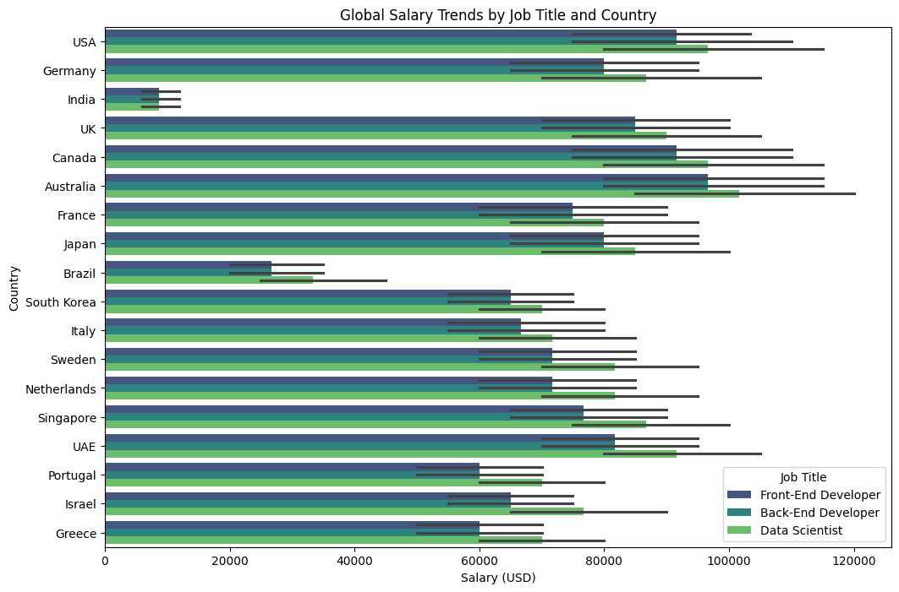

**FIG1: Global salary trends by job title**

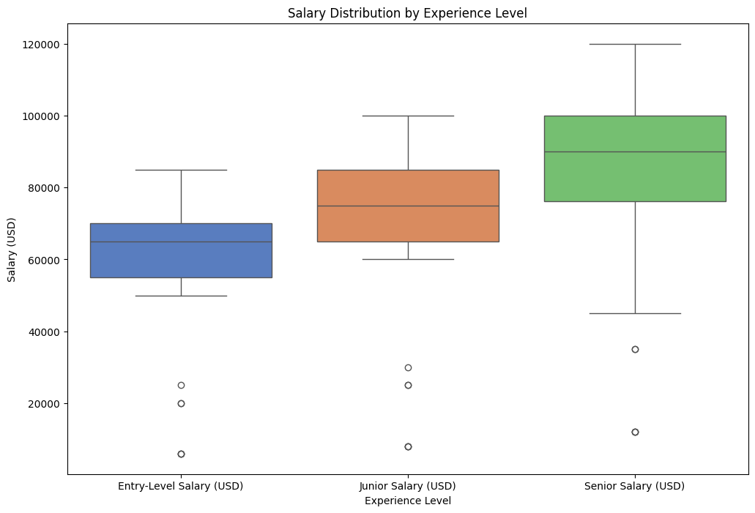

**FIG2: Boxplot of salary distribution by experience level**

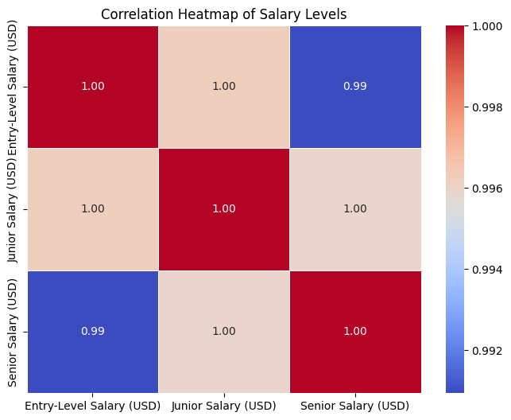

**FIG3: Heatmap of salary levels**

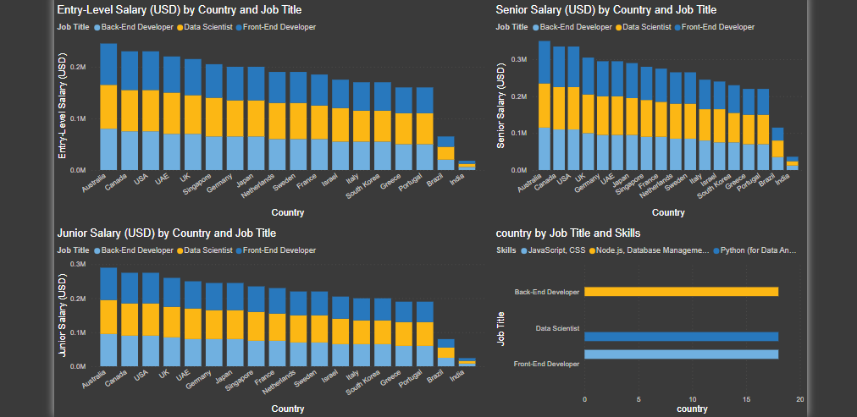

**FIG4: PowerBI dashboard**